**Week 12 Topic Outline – Quantifying Uncertainty**

1. If you had a flight that was leaving at 5:00pm, and you lived 10 miles from the airport, what time would you leave in order to make your flight?
   1. What process would you use to go about selecting when you should leave?
   2. What things do you take into consideration?
   3. But what if…

1. Agents need to handle uncertainty due to partial observability, nondeterminism, or a combination of the two. An agent may never know what state it’s in or where it will end up after it takes a given action.
   1. Remember **logical agents**? These guys considered every logically possible explanation for the observations, no matter how unlikely (called a **belief state**).
   2. This may be okay in a restricted environment, but could lead to impossibly large and complex belief-state representations in others.
   3. Sometimes there is no plan that is guaranteed to achieve its goal (like getting to your flight on time), but that doesn’t mean that you just sit and home instead of trying to make your flight.

1. In situations where some sort of diagnosis is needed, you’re going to be dealing with uncertainty.
   1. Consider the following:

*Toothache => Cavity  
Read: If you have a toothache, then you have a cavity*

* 1. Do you agree?
  2. Do all patients that have toothaches have cavities?

*Toothache => Cavity V GumProblem V Abscess …*

* 1. In order to make this a logical representation, we would have to list all of the possible causes for a toothache.
  2. What if we flipped it?

*Cavity => Toothache*

* 1. Is there ever a situation when a patient can have a cavity that doesn’t hurt?

1. Trying to use logic to cope with complex domains like this fail for three main reasons:
   1. **Laziness** – it is too much work to list the complete set of antecedents or consequents needed to ensure an exceptionless rule and too hard to use those rules.
   2. **Theoretical ignorance** – medical science has no complete theory for the domain.
   3. **Practical ignorance** – even if we know all the rules, we might be uncertain about a particular patient because not all the necessary tests have been or can be run.
   4. You can apply these same reasons for failing in other domains, as well: law, design, business, car repair, gardening, and even dating. Does he/she like me?
2. Uncertainty and rational decisions
   1. Looking back to our example of making our 5:00 flight, say we have a 90% chance of making our flight if we leave at 3:30pm, does that mean it’s a rational choice?
      1. What if we absolutely CANNOT miss the flight and we have a 97% chance of making the flight if we leave at 3:00 instead. Would the 3:00 time be more rational?
      2. What if we had a 100% chance of making the flight if we left at 4:00am (13 hours before it took off)? Would that be a rational choice?
   2. To make these choices, an agent must first have **preferences** between the different possible outcomes of the various plans. An outcome is a completely specified state, including whether the agent arrives on time and the length of the wait at the airport.
      1. We use **utility theory** (useful) to represent and reason with preferences.

**Decision theory = probability theory + utility theory**

* 1. Think about a dating situation where you’re trying to get someone to like you.

*He/She likes me =>*

* + 1. Define the probability theory and its parts
    2. Define the utility theory and its parts

1. Break
2. Probability Notation
   1. For our agent to represent and use probabilistic information, we need a formal language.
   2. In probability theory, the set of all possible worlds is called the **sample space**. Those worlds are mutually exclusive and exhaustive – meaning two worlds cannot both be the case, and one possible world must be the case.
      1. If you roll two dice, there are 36 possible worlds to consider: (1,1), (1,2), …, (6.6).
   3. Ω - Sample Space
   4. ɯ - Possible Worlds
   5. A fully specified probability model associates a numerical probability *P*(ɯ) with each possible world.

0 ≤ *P(*ɯ) ≤ 1 for every ɯ and ∑ *P(*ɯ) = 1

ɯ Ɛ Ω

* 1. The basic axioms of probability theory say that every possible world has a probability between 0 and 1 and that the total probability of the set of possible worlds is 1.
  2. If we assume that each die is fair and rolls don’t interfere with each other, then each possible world (ɯ) has a probability of 1/36. This is the probability theory.

1. Adding more information:
   1. Probabilities such as *P(Total = 11)* and *P(doubles)* are called **unconditional** or **prior probabilities** because they refer to degrees of belief in propositions *in the absence of other information.*
   2. When attempting to make decisions, we often have additional information (often called **evidence**) that has already been revealed.
   3. E.g., the first die may already be showing a 5 and we are waiting for the other one to stop spinning.
   4. In this case, we are interested not in the unconditional probability of rolling doubles, but rather the **conditional**  or **posterior** probability of rolling doubles *given that the first die is a 5.*

*P(doubles* | *Die1 = 5)*

* 1. Answer these:
     1. *P(doubles) = ?*

*P(doubles) = P(1,1) + P(2,2) + P(3,3) + P(4,4) + P(5,5) + P(6,6)  
P(doubles) = 1/36 + 1/36 + 1/36 + 1/36 + 1/36 + 1/36 = 6/36  
P(doubles) = 1/6*

* + 1. *P(doubles* | *Die1 = 3) = ?*

*P(doubles* | *Die1 = 3) = P(3)*

*P(doubles* | *Die1 = 3) = 1/6*

* 1. Conditional probabilities are defined in terms of unconditional probabilities as follows: for any propositions ***a*** and ***b***, we have:

*P(****a***|***b****) = P (****a***and***b****) / P(****b****)*

1. Given the following chart:

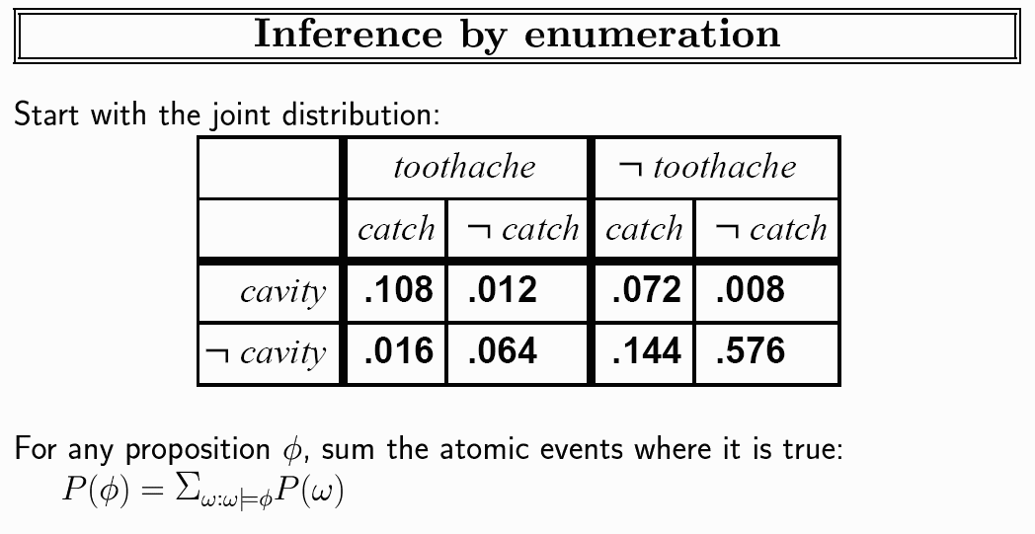

Answer these:

*P(cavity* V *toothache) =* 0.108 + 0.012 + 0.072 + 0.008 + 0.016 + 0.064 = **0.28**

*P(cavity) =* 0.108 + 0.012 + 0.072 + 0.008 = **0.2**

*P(cavity* ^ *– toothache) =* 0.072 + 0.008 = **0.08**